**Contacting your GP for Yourself**

This article explains how to submit a request for help for yourself using Patchs.

You will need to login each time to retrieve messages and to check on the progress of your request.

**Submitting a request for yourself**

Once you are registered and logged into Patchs, click on the **Make a Request**link at the top of the page.

This will load the **How can we help you?**page, where you need to click the **Myself**button.

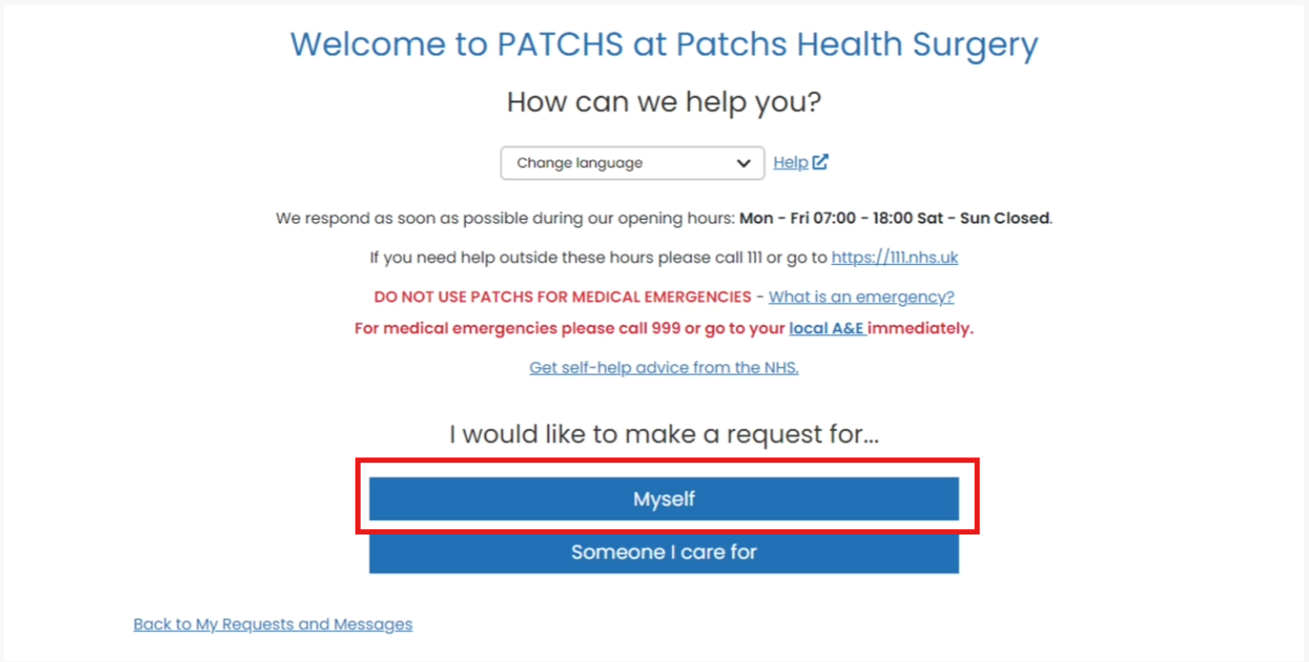

You can then click on the button that best describes your type of request.

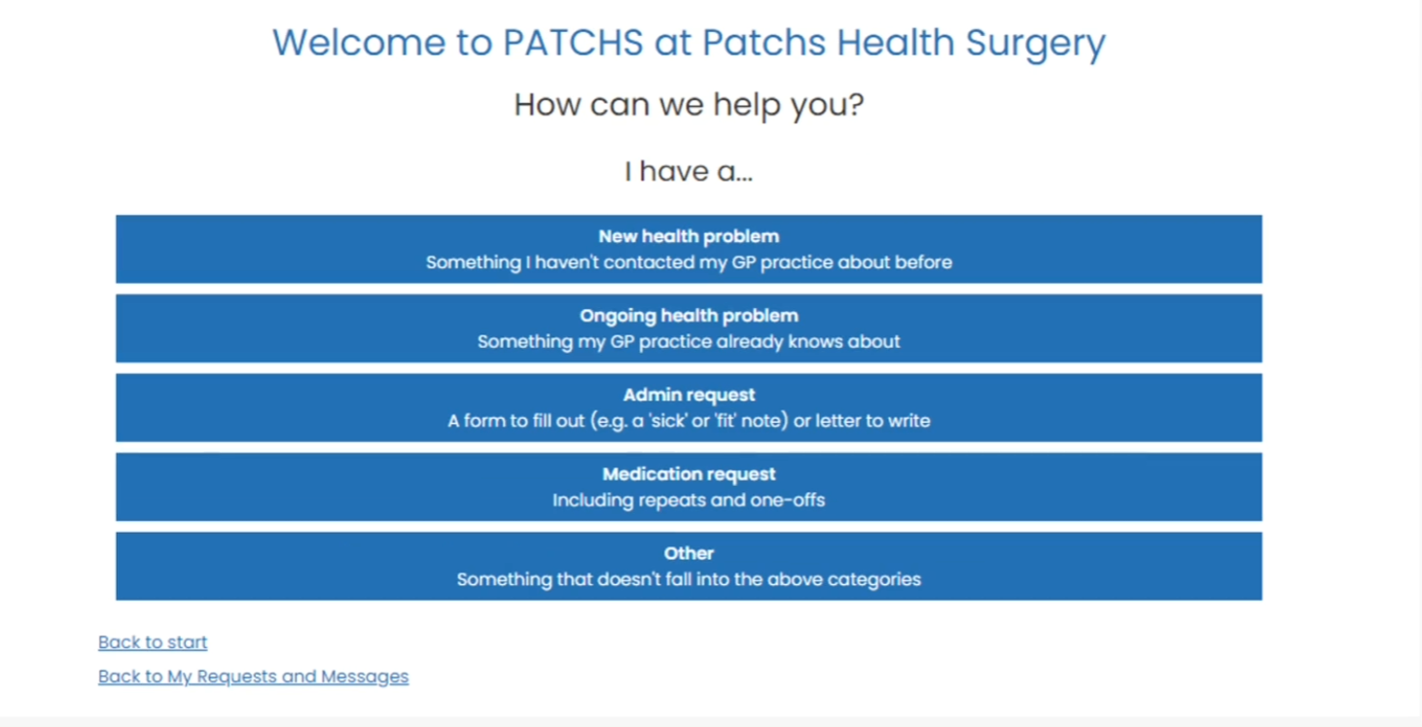

Now you will then see 3 warning messages:

* Emergency warning - you need to confirm that you are not potentially experiencing a medical emergency. Patchs cannot be used for this purpose because the GP practice will be unable to respond quickly enough in this situation.

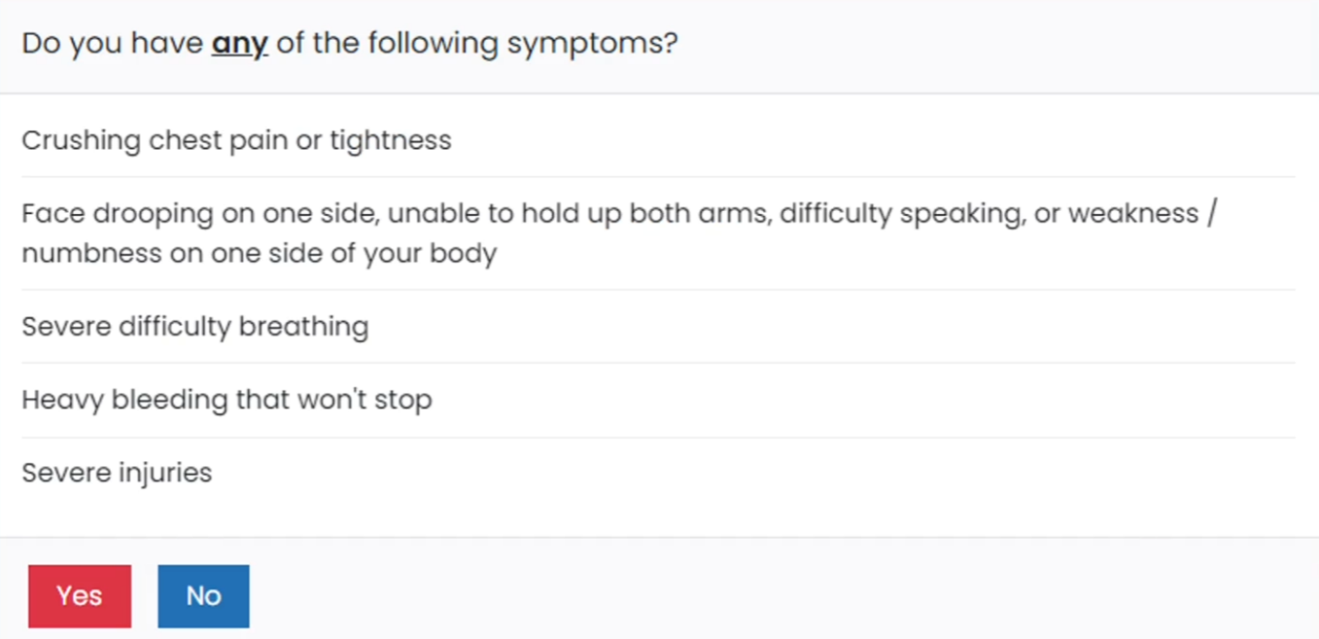

* Confirm details warning - this is to ensure your contact information is up to date so the GP practice can respond to you.

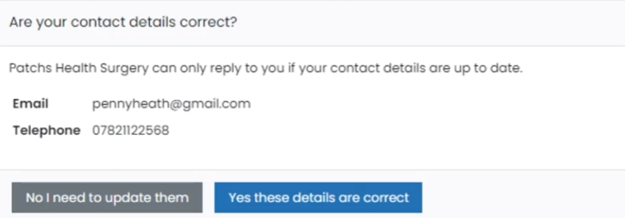

* General information warning - this gives you guidance on what to expect while submitting a Patchs request, including how long you have to submit your request.

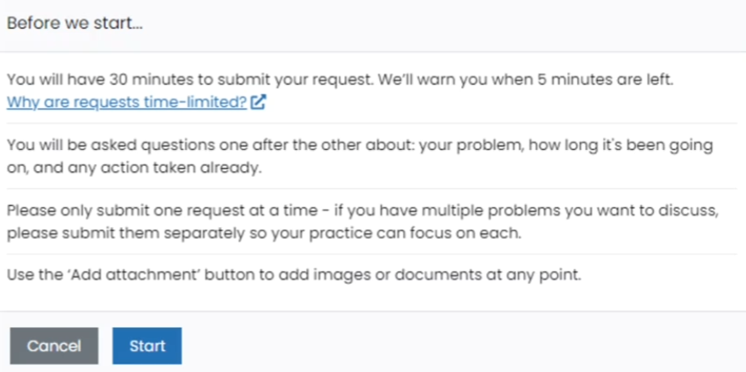

Click on the blue **Start** button.

You will be taken to the Patchs chatbot, where you will be asked a few simple questions to help your GP understand more about your request.

Answer each question in turn, using the **Submit**button when your answer is complete.

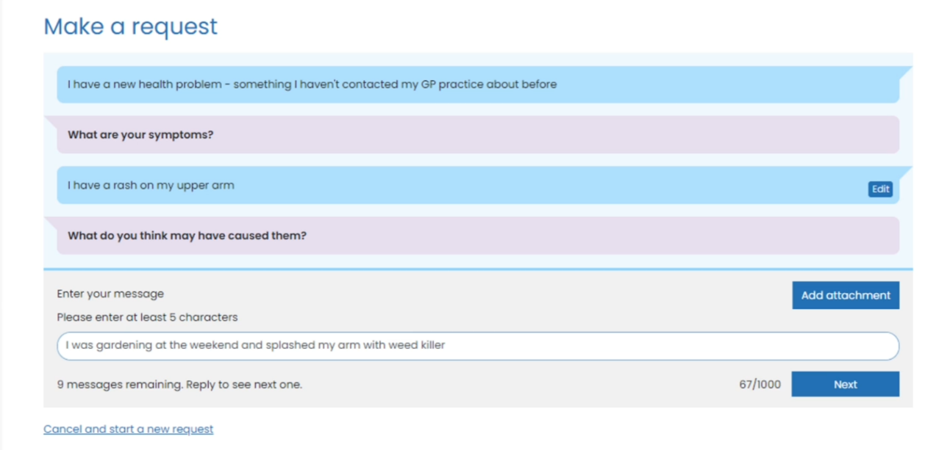

*Please note the chatbot provides fixed questions/responses. It is not a human or an Artificial Intelligence Agent responding.*

An **Edit** button is shown alongside each response. If you click the **Edit** button, you will be able to amend your answers from within the chatbot.

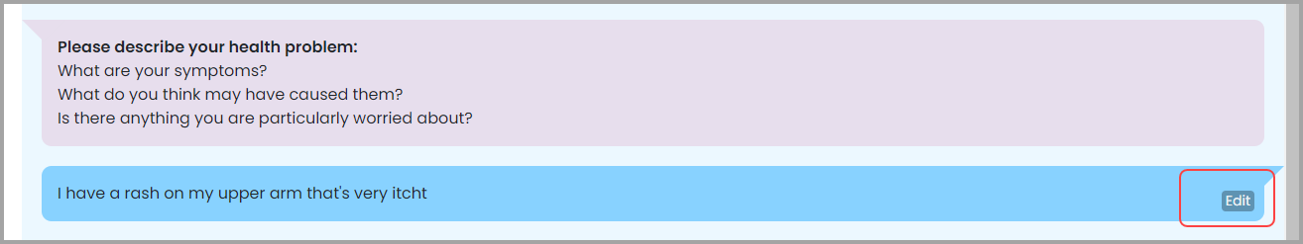

You can click the **Add Attachments**button to attach an image or a document as additional information for your request. You should only upload sensitive images if you are asked to do so by your GP.

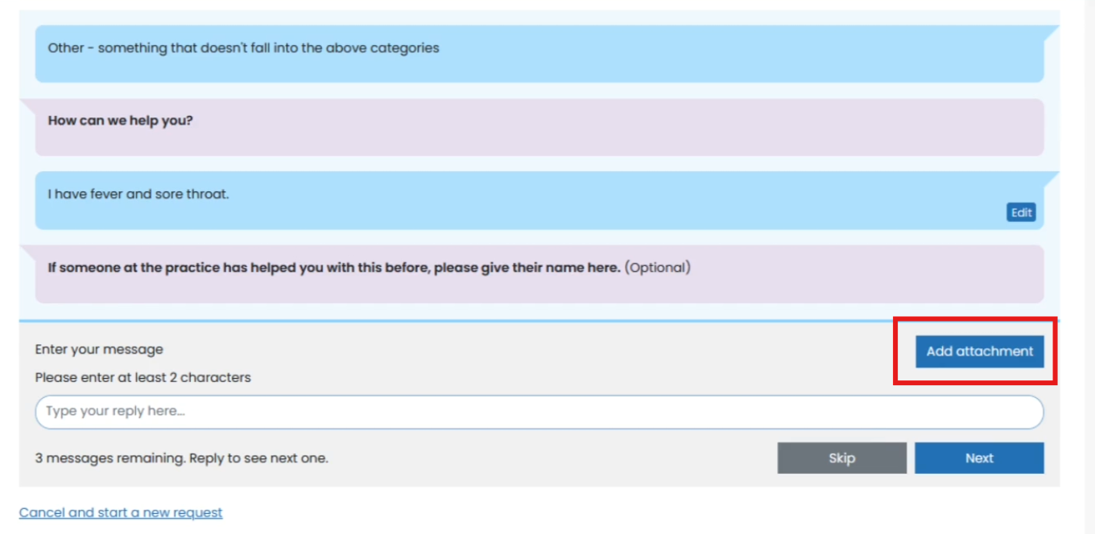

If it is a sensitive image, you can mark it as such, and it will not be displayed to anyone except the GP.

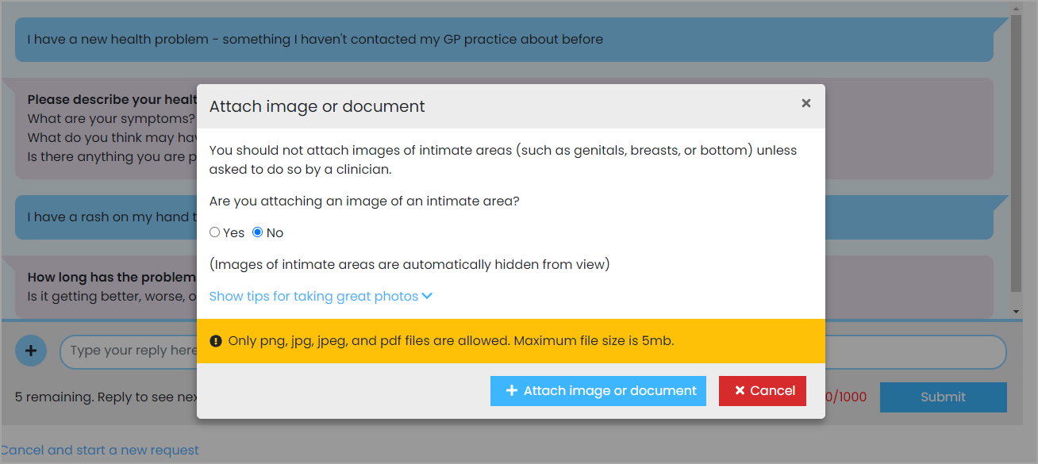

When you have answered and edited all your responses you will be asked to **Confirm** your responses. Clicking **Confirm** means that you agree for your responses to be added to your GP record.

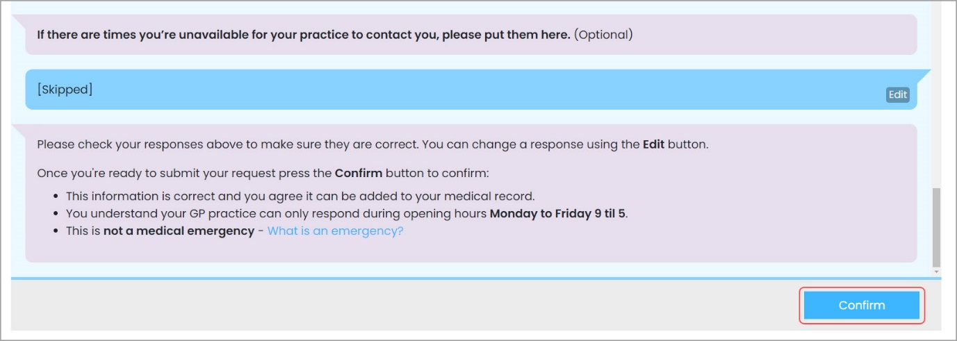

Once you click the **Confirm**button, your request will be sent to the practice.

A **confirmation email** will be sent to both you and to the GP practice, so that they can respond to your request.

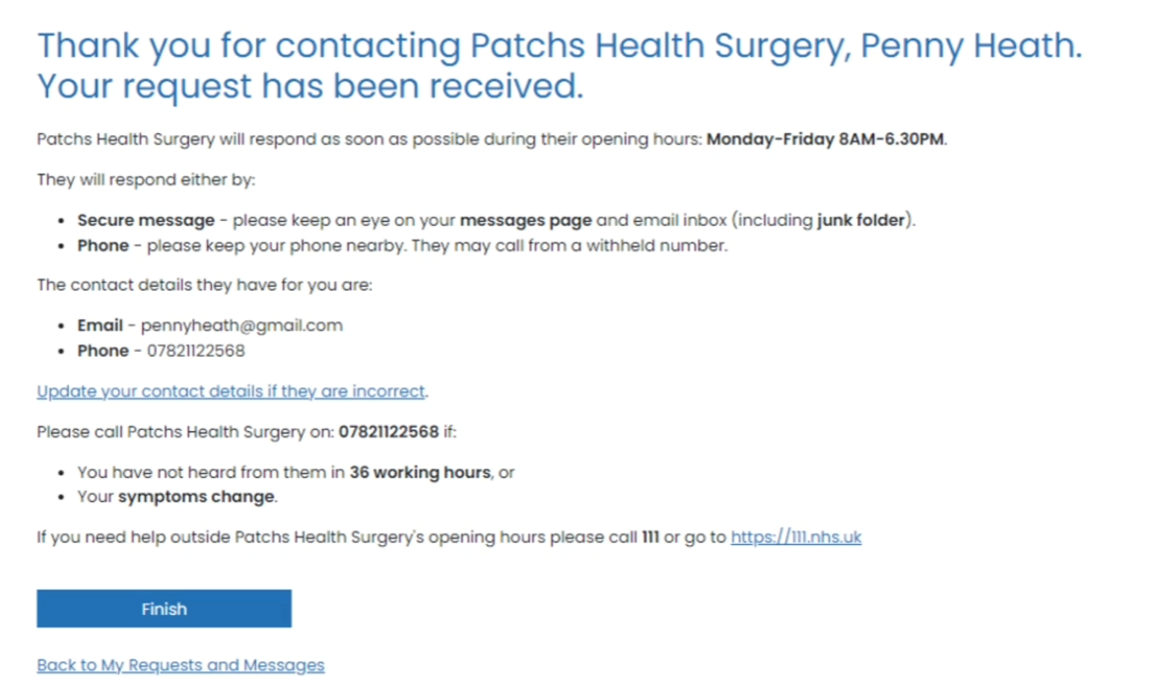

If you want to check on the progress of your request, or if your practice sends you a follow-up question that you need to respond to, click on the **My Requests & Messages**link at the top of your Patchs page.

Here, you will see your past requests. You can open a request by clicking anywhere on its entry in the table.

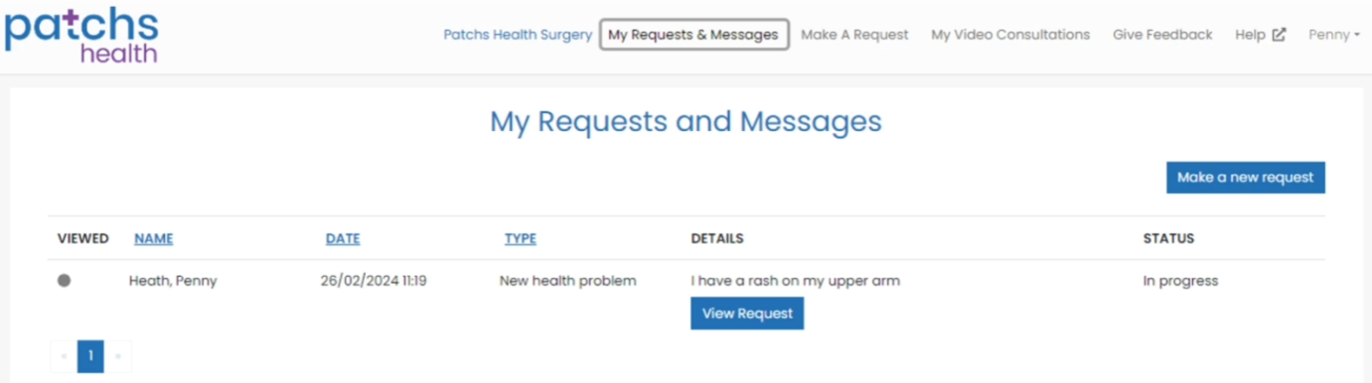

Clicking on a request will display your conversation with your practice.