**Contacting your practice via the NHS App**

**Asking for help for a medical issue via the NHS App**

To contact the practice for help with a medical issue, load the NHS App and then:

1. Choose**Services**from the lower left of the screen
2. Select **Contact your GP about a health problem**
3. Then select **Continue**to access Patchs
4. Then choose either:   
   * **New health problem**- for something you haven't contacted your GP practice about before.
   * **Ongoing health problem** - for something your GP practice already knows about.

Having chosen your request type, you will need to answer a few questions and confirm your answers to submit your request.

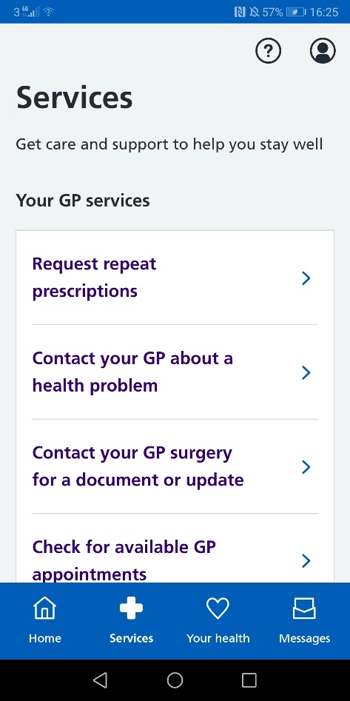

Screenshot of the NHS app footerScreenshot of the NHS app footer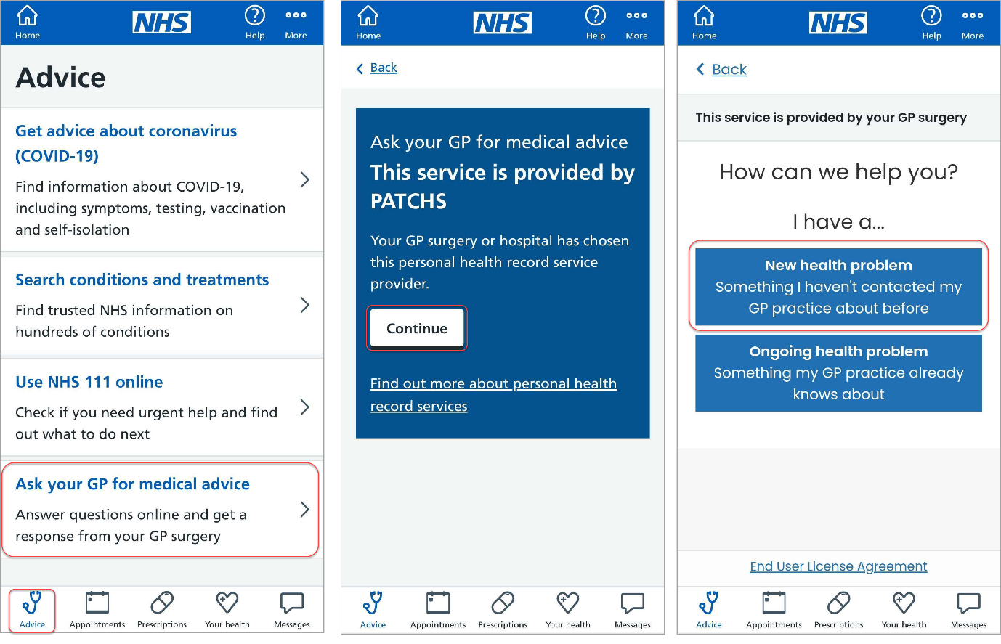

Screenshot of the NHS app thank you pageScreenshot of the NHS app footer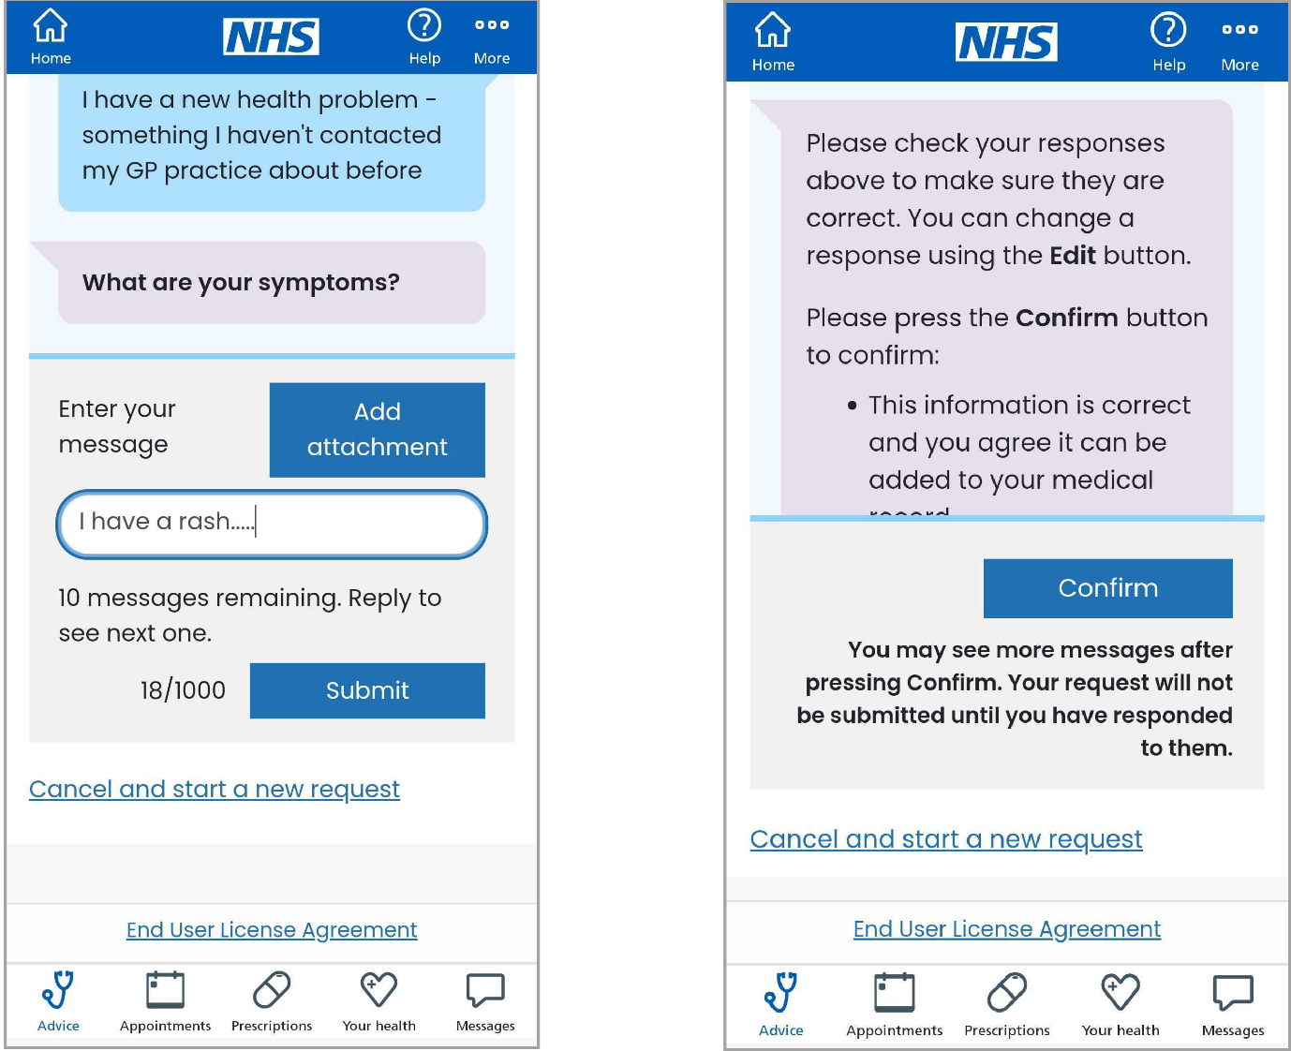

Once you have successfully submitted your request you'll be taken to a confirmation page.

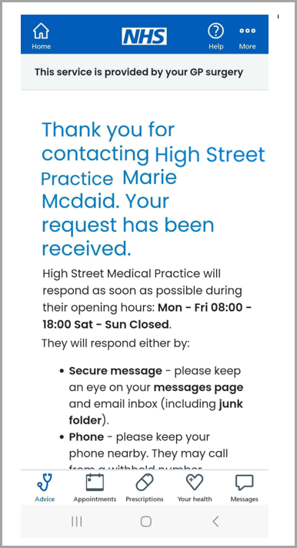

Screenshot of the NHS app footer

**Asking for help with an admin query via the NHS App**

To contact the practice for help with an admin query, load the NHS App and then:

1. Choose **Messages** from the lower left of the screen
2. Select **View responses, check your past requests or send a new request**
3. Click **Continue**to access Patchs
4. Screenshot of the NHS app footerScreenshot of the NHS app footerScreenshot of the NHS app footerChoose **Ask for a fit note (sick note), or other documents**to submit an admin query.

Having chosen to ask your GP practice a question, you will need to answer a few questions and confirm your answers to submit your request.

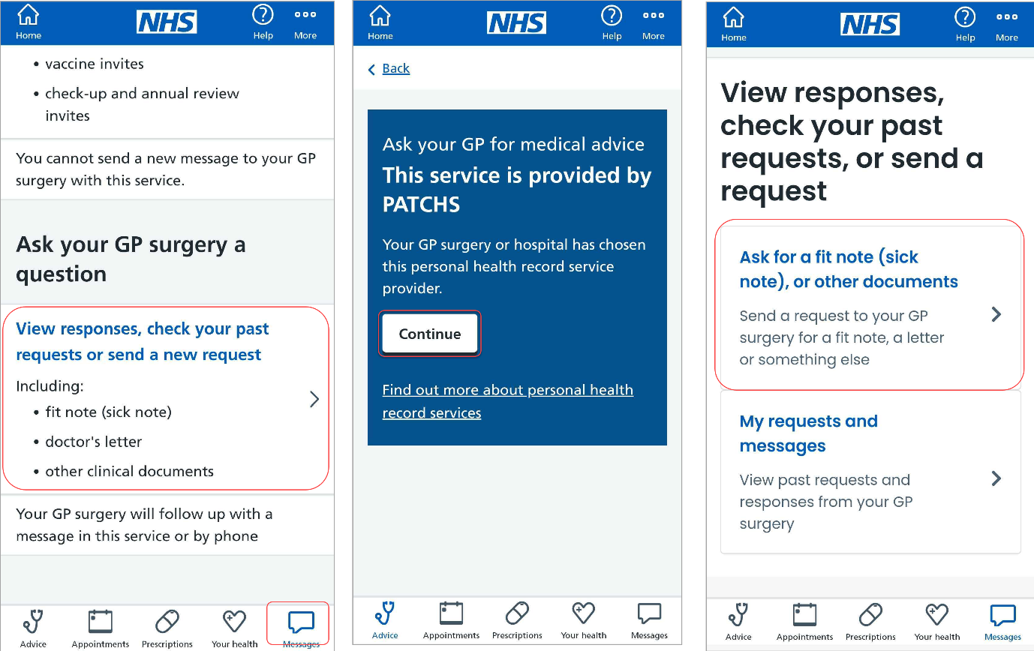

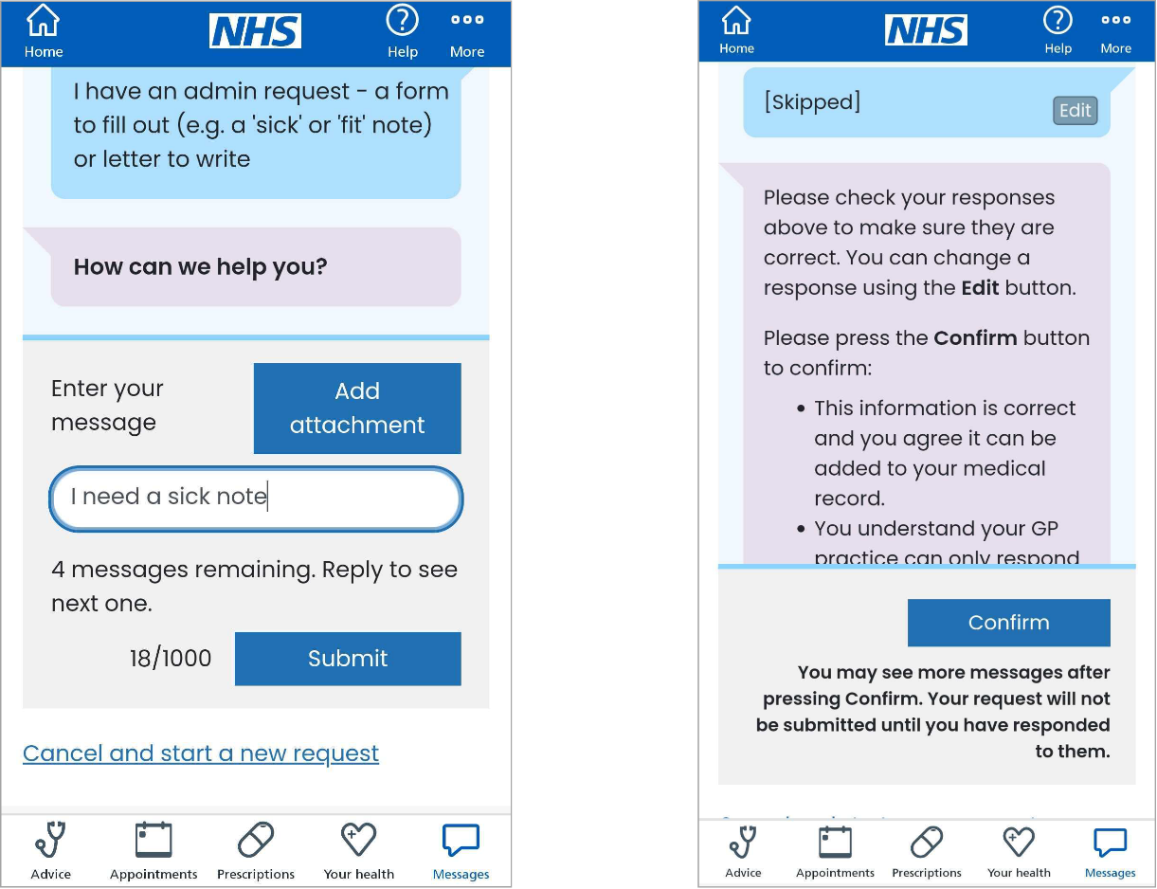

Once you have successfully submitted your request, you'll be taken to a confirmation page.



**Reading and responding to a Patchs message via the NHS App**

To read and respond to a Patchs message, load the NHS App and then:

1. Choose **Messages** from the bottom left of the screen
2. Select **View responses, check your past requests or send a new request**
3. Click **Continue**to access Patchs
4. Screenshot of the NHS app footerScreenshot of the NHS app footerScreenshot of the NHS app footerChoose **My requests and messages**to view past requests and responses from your GP practice

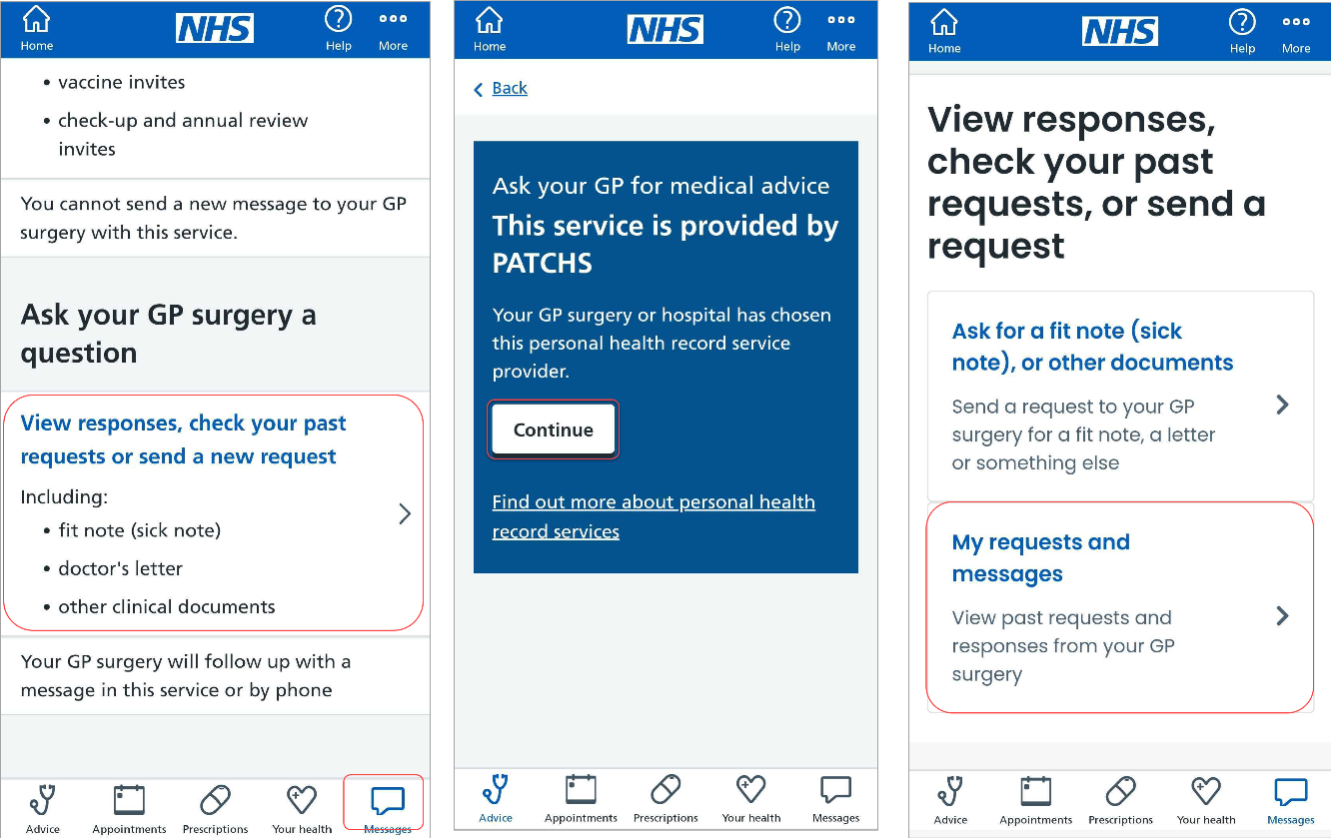You will then be taken to **My Requests and messages,**where you can view your past requests and respond to any messages.

Screenshot of the NHS app footer