**Changing your Details**

This explains how to change the personal and contact details held for you by your GP practice. You can do this from within Patchs by submitting an **Admin Request**.

Simply follow these steps:

1. Log into Patchs.
2. Click on your name in the top right corner to reveal a dropdown menu.
3. Select the **Change My Details** link.

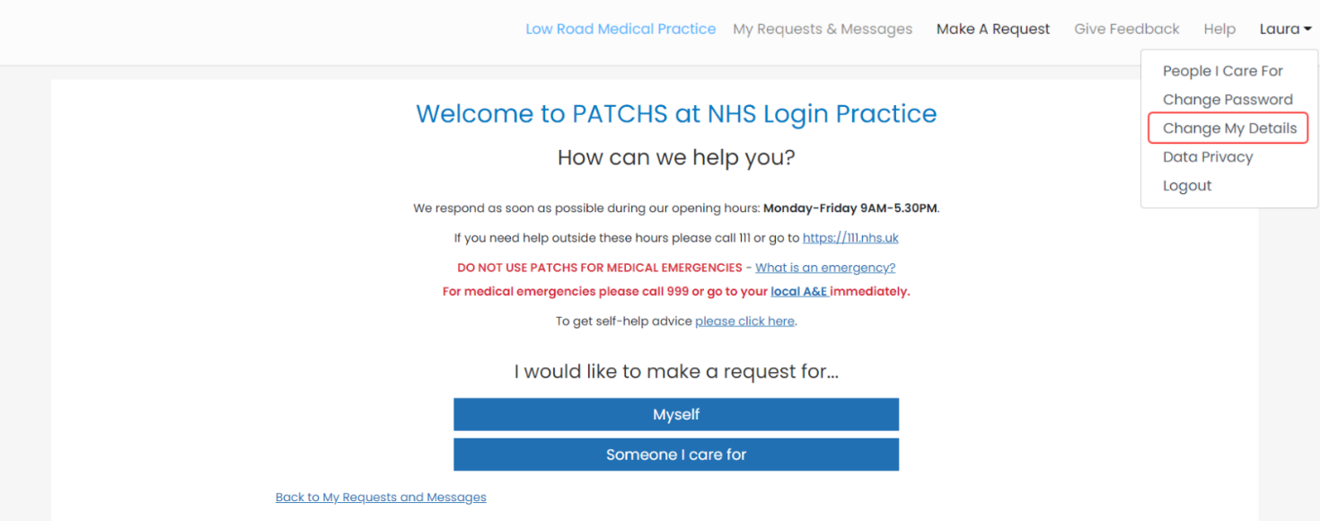

This will load the **Change My Details**page.

Here, you can amend your details.

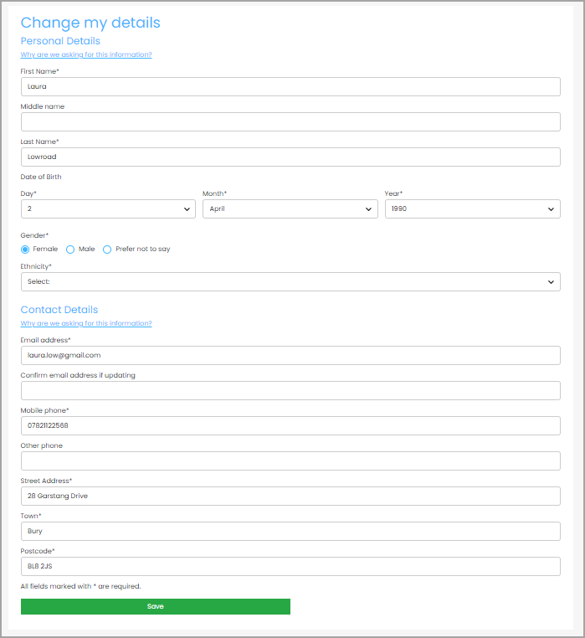

When you have finished, click the **Save**Button.