**Changing your Password**

This article explains how to change your password in Patchs. The process will be different depending on whether you usually login:

1. [with your Patchs account](https://help.patchs.ai/hc/en-gb/articles/360058801653-Changing-your-Password#h_01HCA2F137ZKF8W3G3B4QER33Z), or:
2. [with your NHS Login](https://help.patchs.ai/hc/en-gb/articles/360058801653-Changing-your-Password#01HCCEPZZEYJPQT3FD2774BF2K)

**Changing your password when you usually login with a Patchs account**

1. Log into Patchs in the way you usually do, using your email address and your Patchs password.
2. Once you are logged in, click on your name in the top right corner of the screen. This will reveal a dropdown menu.
3. Select the **Change Password**link.

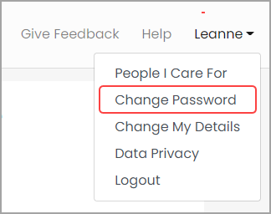

If you initially registered with Patchs by creating a Patchs account (ie, by using your email address and creating a password), this will load the **Change Password**page inside Patchs.

Here, you should enter your new password. When you are happy with your password and have confirmed it, click the **Save**button to finalise the change.  
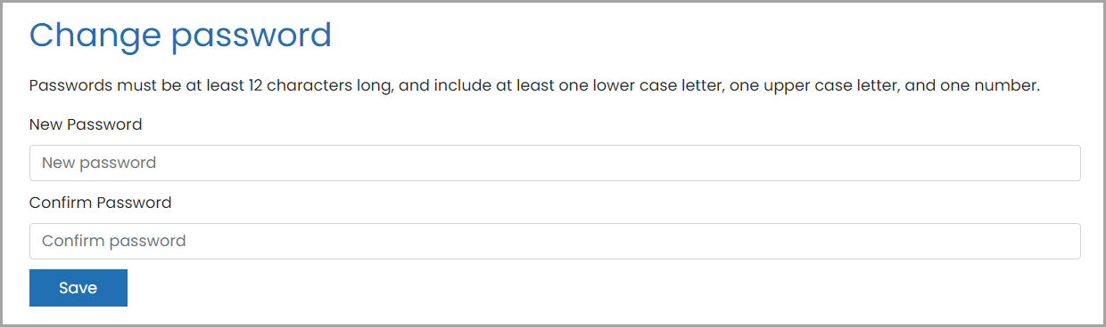

Your password has now been updated, and you should use this new password to login to Patchs in future.

**Changing your password when you usually login with NHS Login**

1. Log into Patchs in the way you usually do, using your NHS Login.
2. Once you are logged in, click on your name in the top right corner of the screen. This will reveal a dropdown menu.
3. Select the **Manage NHS Login Account**link.

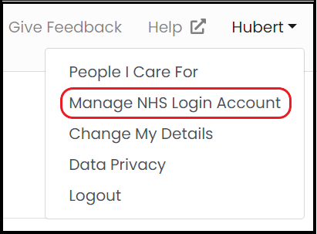

You will now be redirected to the NHS login page. From here, you should follow these steps:

1. Click on **Login and security settings**:

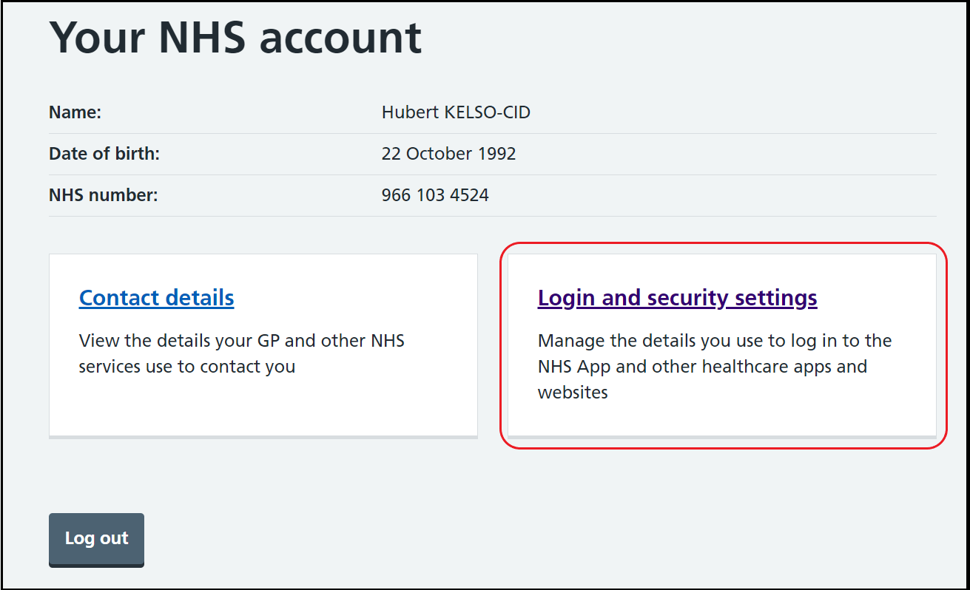

2. Under 'NHS account login details,' click the **Change** button next to your password:

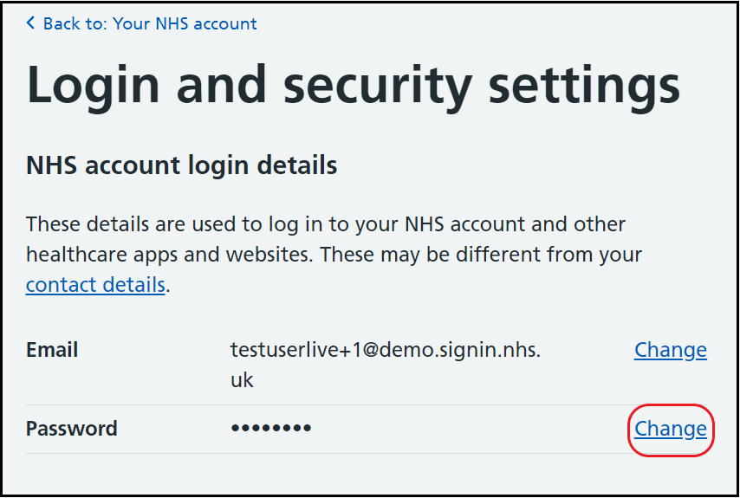

3. Enter your current password:

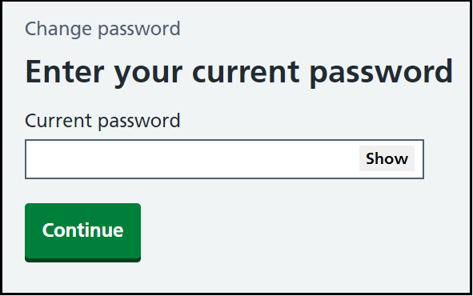

4. Now, enter the password you wish to change to. Type it again in the box below to confirm it. Now click **Change password** to finalise the change.

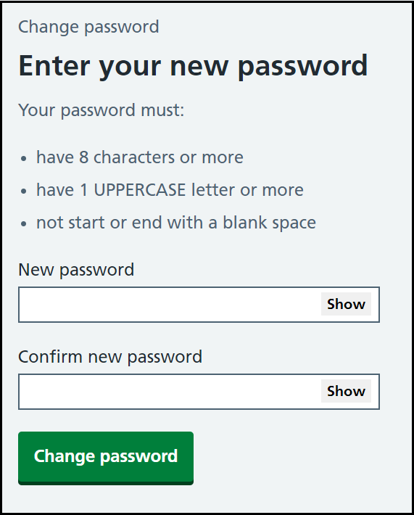

Your password has now been updated, and you should use this new password to login to Patchs in future.